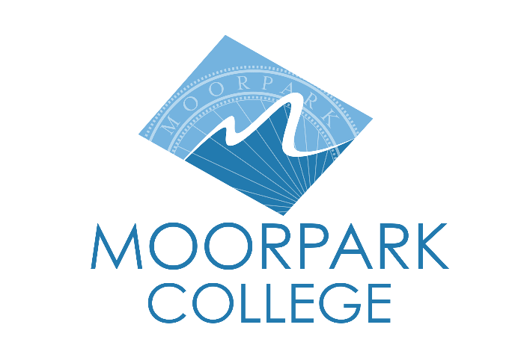

FOR IMMEDIATE RELEASE

Moorpark College Theatre Arts Announces Auditions for Angels In America: Part One — Millennium Approaches
Open auditions welcome students and community members for a bold, ensemble-driven production of Kushner’s acclaimed play

Moorpark, Calif. (July 30, 2025) — This fall, the Moorpark College Theatre Arts Department will present Angels in America: Part One — Millennium Approaches, Tony Kushner’s landmark play exploring politics, identity and the AIDS crisis in 1980s America. Auditions will be held August 12-14 at the Moorpark College Performing Arts Center.

The production calls for a large, versatile cast and offers a range of challenging roles that span gender, race, and age. All lead roles will likely be double cast, and auditions are open to Moorpark College students and the wider community. Rehearsals begin August 18, with evening rehearsals held Monday through Thursday.

Regarded as a definitive theatrical work on the AIDS crisis, Angels in America is set in 1980s New York and follows Prior, a gay man diagnosed with AIDS, whose partner Louis leaves him and begins a relationship with a married man. As Prior’s illness progresses, an angel appears and names him a prophet. The cast includes an Orthodox rabbi, an imaginary travel agent, a medieval farmer, an Inuk (a person of Inuit heritage) and historical figures Roy Cohn and Ethel Rosenberg. The work explores otherness, queerness, faith, addiction, and mortality.

The play won the Pulitzer Prize for Drama, the Tony Award for Best Play and the Drama Desk Award for Outstanding Play in 1993.

“I was planning on producing Angels in America right before the COVID-19 pandemic hit,” said Suzanne Fagan, director. “Now I think it is extremely interesting to do the play after many of us lived through that time since many students were not around during the AIDS pandemic. I am very excited to explore this play with them, many of whom identify with the LGBTQ+ community or as an ally.”

Auditions will take place at the Moorpark College Performing Arts Center on Tuesday, August 12, from 3:30–6:00 p.m. and Wednesday, August 13, from 6:00–9:00 p.m., with callbacks on Thursday, August 14, from 3:30–6:00 p.m. Those cast must enroll in a 3-unit Theatre Production: Performance course (THA M10A–D). For full audition details, visit moorparkcollege.edu/theatre-arts/auditions-and-rehearsals.

About Moorpark College
Moorpark College is one of three colleges in the Ventura County Community College District and annually serves more than 14,000 students. Founded in 1967, Moorpark College is fully accredited and has the highest six-year completion rate within the California Community College System. An Aspen Institute Top 10 Finalist for 2023 and 2025, Moorpark College has also been named a 2020 Champion of Higher Education by The Campaign for College Opportunity for the Associate Degree for Transfer Pathway. It is also a designated Hispanic-Serving Institution. The college’s signature career/technical programs include nursing, radiologic technology, biotechnology and journalism. The college’s America’s Teaching Zoo is the only associate degree exotic animal training program in the country. To learn more, visit MoorparkCollege.edu or follow @MoorparkCollege on social media.

Media Contact:
John Loprieno
Theatre Arts Faculty
Moorpark College
(805) 378-1469

