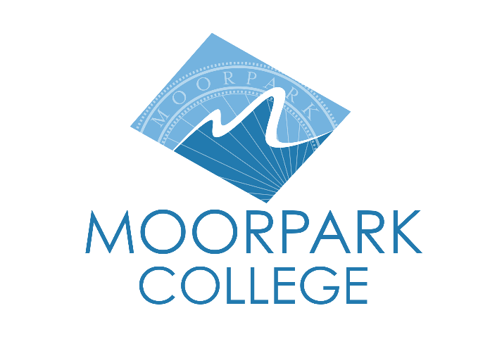

FOR IMMEDIATE RELEASE

Moorpark College Theatre Arts Presents Angels In America: Part One — Millennium Approaches
Ensemble cast explores love, loss and identity in Kushner’s Pulitzer-winning AIDS-era epic

Moorpark, Calif. (Sept. 24, 2025) — This fall, the Moorpark College Theatre Arts department brings Angels in America: Part One — Millennium Approaches to the Performing Arts Center. The production will run October 9-19, with evening performances Thursday through Saturday and Sunday matinees.

Tony Kushner’s landmark drama — set in 1980s New York during the height of the AIDS crisis — follows Prior, a gay man diagnosed with AIDS who is visited by an angel and named a prophet. Widely regarded as a definitive theatrical work on the era, the play explores themes of otherness, queerness, faith, addiction and mortality while weaving historical figures such as Roy Cohn and Ethel Rosenberg into its vivid tapestry.

“One of the things I relate to the most is the difficulty of never having a slow moment for vulnerability,” said Casey Mora, who plays Prior. “Prior brings his emotions, experiences and doubts in an unfiltered way that sometimes might not be digestible and could be suffocating for others. That lack of hesitation is something I can relate to, being candid. His attempt to reclaim his femininity throughout the production is the epitome of who he is.”

“I have never portrayed a character so vulnerable, and I don’t get to be this vulnerable in my everyday life,” said Dash Jeffords of his role as Prior’s partner Louis. “Through this character and telling his story, I’ve been able to go back to my life and better myself as a person by utilizing what I learn through the role.”

“Having the chance to explore the inner workings of such a complex, acerbic and widely reviled character is incredibly exciting,” said Brett Lawrence, who plays Roy Cohn. “It has also been both enlightening and frightening to learn more about how the things that Roy Cohn did and the people he influenced are still impacting us every day.”

The department previously produced the comedy Our Lady Of The Tortilla. This year’s production of Angels in America is a continuation of the Theatre Arts Department’s commitment to highlight their diverse student body through powerful, ensemble-driven work.

Performances will be held at 8 p.m. Oct. 9-11 and Oct. 16-18 and at 2 p.m. Oct. 12 and 19 on the main stage of the Moorpark College Performing Arts Center. Tickets are $15 for students and seniors and $20 for adults with a 20% discount for online orders. Purchase tickets at (805) 378-1485 or moorparkcollege.edu/pac.

About Moorpark College
Moorpark College is one of three colleges in the Ventura County Community College District and annually serves more than 14,000 students. Founded in 1967, Moorpark College is fully accredited and has the highest six-year completion rate within the California Community College System. An Aspen Institute Top 10 Finalist for 2023 and 2025, Moorpark College has also been named a 2020 Champion of Higher Education by The Campaign for College Opportunity for the Associate Degree for Transfer Pathway. It is also a designated Hispanic-Serving Institution. The college’s signature career/technical programs include nursing, radiologic technology, biotechnology and journalism. The college’s America’s Teaching Zoo is the only associate degree exotic animal training program in the country. To learn more, visit MoorparkCollege.edu or follow @MoorparkCollege on social media.

Media Contact:
John Loprieno
Theatre Arts Faculty
Moorpark College
(805) 378-1469

