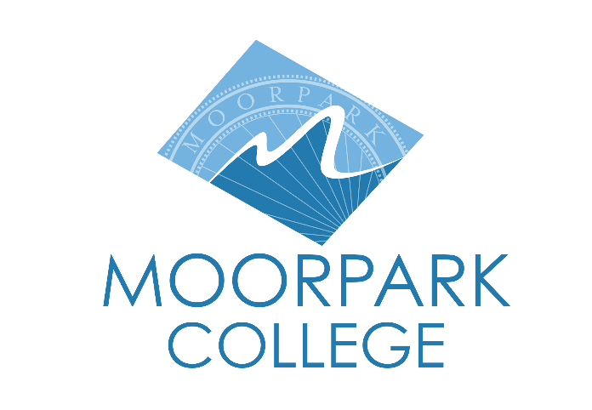

FOR IMMEDIATE RELEASE

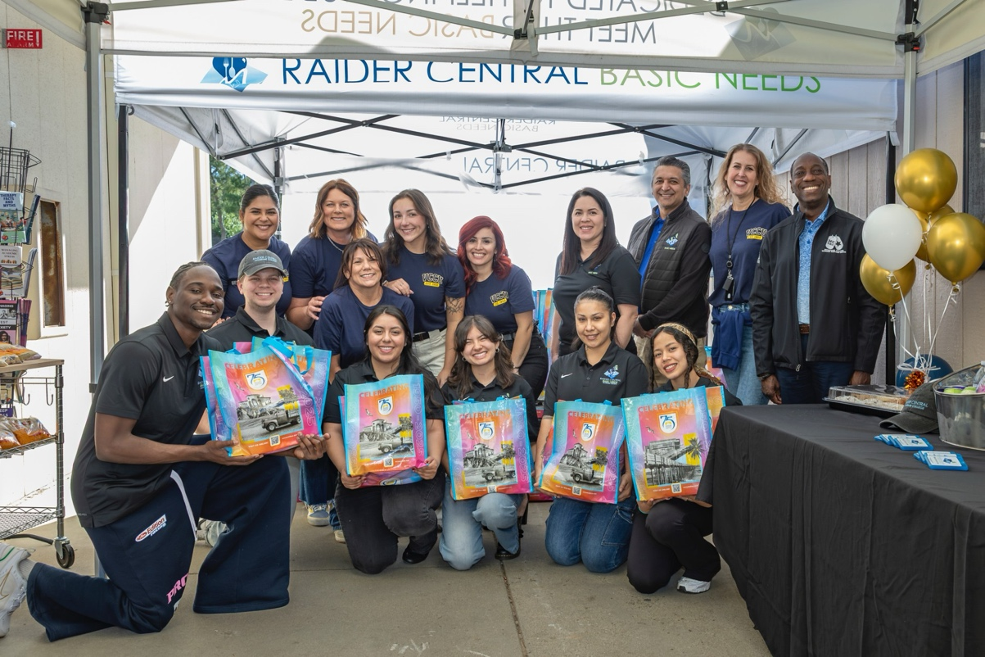

Community Commitment Advances Student Opportunity at Moorpark College
$75,000 donation to provide scholarships, basic needs, and student-centered programs that shape the future of Ventura County

Moorpark, Calif. (Dec. 17, 2025) — Moorpark College is deepening its commitment to student success with the support of a $75,000 donation from Ventura County Credit Union (VCCU), which will help expand scholarships, basic needs programs and student-centered initiatives across campus. This gift was presented to the college as a part of VCCU’s “Year of Giving.”

“We are deeply grateful for VCCU’s extraordinary investment in our students,” said Dr. Julius Sokenu, president of Moorpark College. “This generous gift strengthens the programs that open doors, empower learners and uplift families across Ventura County. VCCU’s commitment to education reflects the very best of community partnership, and together we are helping our students build futures filled with purpose and possibility.”

The donation also reflects VCCU’s ongoing engagement with students beyond the classroom.

On Friday, December 12, VCCU leadership and staff packed and delivered 88 bags of hygiene items, diapers and resources for students in need. By helping students meet their basic needs with dignity, this kind of support removes barriers to learning and directly contributes to persistence, achievement, and long-term success.

“Our roots are deeply tied to this community and supporting local education is one of the most meaningful ways we can give back,” said Linda Rossi, president and CEO of Ventura County Credit Union. “For 75 years, we’ve been committed to helping our members and our community thrive. This gift represents our continued investment in the people and institutions that make Ventura County stronger.”

These contributions are some of many ways Moorpark College is working with community partners to remove barriers, expand access, and support every student’s path to success. To learn more or support our student programs, visit moorparkcollege.edu/foundation

About Moorpark College
Moorpark College is one of three colleges in the Ventura County Community College District and annually serves more than 14,000 students. Founded in 1967, Moorpark College is fully accredited and has the highest six-year completion rate within the California Community College System. An Aspen Institute Top 10 Finalist for 2023 and 2025, Moorpark College has also been named a 2020 Champion of Higher Education by The Campaign for College Opportunity for the Associate Degree for Transfer Pathway. It is also a designated Hispanic-Serving Institution. The college’s signature career/technical programs include nursing, radiologic technology, biotechnology and journalism. The college’s America’s Teaching Zoo is the only associate degree exotic animal training program in the country. To learn more, visit MoorparkCollege.edu or follow @MoorparkCollege on social media.

Media Contact:
communications@vcccd.edu
805-652-5502

