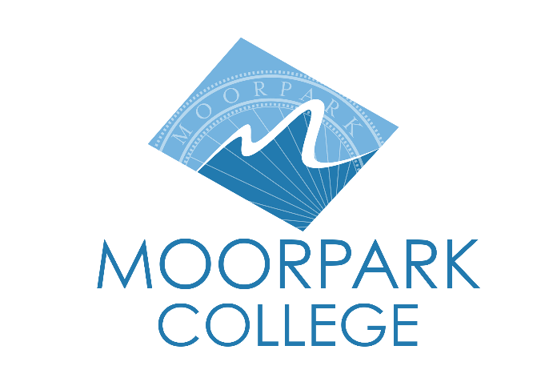

FOR IMMEDIATE RELEASE



Moorpark College Named 2025 Pathway Champion for Driving Equity in Transfer Success
Statewide recognition highlights Moorpark's commitment to advancing student access and achievement

Moorpark, Calif. (Oct. 20, 2025) — At Moorpark College, transfer isn’t just a hope—it’s a plan. This year, the college’s work to remove barriers, close equity gaps and accelerate student success has earned it statewide recognition as a 2025 Pathway Champion of Transfer. This honor presented by the Campaign for College Opportunity recognizes colleges with the top numbers of Associate Degrees for Transfer (ADTs) awarded relative to full-time student enrollment.

Through California’s Associate Degree for Transfer (ADT) program, which guarantees CSU admission for students who complete aligned coursework, more than 450,000 degrees have been awarded statewide. At Moorpark, a focused and equity-driven rollout of the ADT has helped more students, especially those from families and neighborhoods who face extra hurdles getting to college, reach their transfer goals.

“This recognition shines a spotlight on the relentless commitment to making transfer pathways clear, equitable and student-centered,” said Julius Sokenu, president of Moorpark College. “Moorpark’s leadership in advancing Associate Degrees for Transfer, supporting students in the journey to four-year institutions and closing opportunity gaps exemplifies what it means to be a true champion in higher education.”
Across California, colleges are reimagining the transfer experience—not just increasing degrees awarded, but redesigning systems to support students every step of the way. Moorpark College is one of 40 campuses recognized for turning that vision into measurable results. This progress reflects a broader districtwide effort to align policy with practice—making transfer a supported, expected outcome for students across Ventura County.

“Our mission as a district is to ensure that every student has a clear, supported path to reach their goals,” said Rick MacLennan, chancellor of the Community Colleges of Ventura County. “Moorpark College’s success reflects the power of intentional design, strong partnerships and shared commitment to helping students move confidently from our classrooms to four-year universities.”
The 2025 Pathway Champions will be recognized during a virtual event on October 23 as part of National Transfer Week. To learn more about Moorpark College’s transfer programs and student support services, visit moorparkcollege.edu.
About Moorpark College
Moorpark College is one of three colleges in the Ventura County Community College District and annually serves more than 14,000 students. Founded in 1967, Moorpark College is fully accredited and has the highest six-year completion rate within the California Community College System. An Aspen Institute Top 10 Finalist for 2023 and 2025, Moorpark College has also been named a 2020 Champion of Higher Education by The Campaign for College Opportunity for the Associate Degree for Transfer Pathway. It is also a designated Hispanic-Serving Institution. The college’s signature career/technical programs include nursing, radiologic technology, biotechnology and journalism. The college’s America’s Teaching Zoo is the only associate degree exotic animal training program in the country. To learn more, visit MoorparkCollege.edu or follow @MoorparkCollege on social media.

Media Contact:
communications@vcccd.edu
805-652-5502

