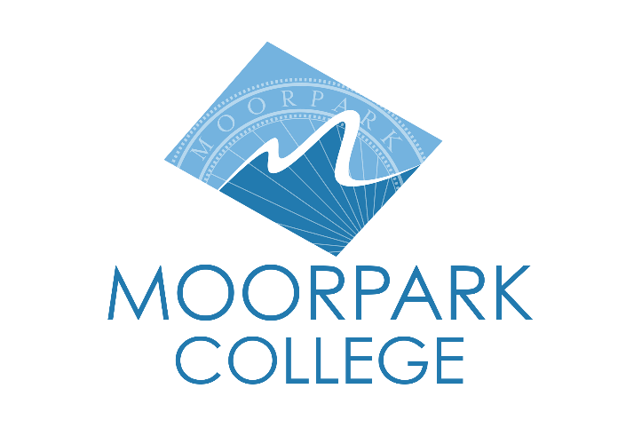

FOR IMMEDIATE RELEASE

Moorpark College Celebrates Grand Opening of Expanded MakerSpace
Community Invited to Explore Innovative 1,900 Square Foot Facility on Wednesday, October 22

Moorpark, Calif. (Sept. 18, 2025) — Moorpark College will officially open the doors to its newly expanded MakerSpace at its grand opening celebration on Wednesday, October 22. This exciting milestone marks a new chapter for one of the college's most transformative programs, now housed in a state-of-the-art facility at the heart of campus.
The grand opening celebration will offer attendees an opportunity to explore the new space, meet program staff and discover the incredible resources available to students and the broader community. From cutting-edge technology to collaborative workspaces, the expanded MakerSpace represents a hub of creativity and innovation designed to inspire makers of all skill levels.
This expansion consolidates 8 years of innovative programming into a unified 1,900-square-foot facility located in the Technology Business Building. The program has transformed student learning and career preparation since its inception in 2017.
"The MakerSpace experience is a catalyst to move students from career exploration to career preparedness while building self-efficacy and flexing the maker mindset," said Clare Sadnik, founder of the Moorpark College MakerSpace. "Over the years I have seen students transform, gaining the self-confidence they needed to transfer to a four-year institution or seek new careers because of their involvement with MakerSpace."
The MakerSpace program began in 2017 through the California Community Colleges (CCC) Maker Initiative, with Moorpark College selected as one of only 24 community colleges statewide to receive funding to create a campus MakerSpace and integrate a culture of making into the campus community. Over the past 8 years, the program has evolved into a multidisciplinary creative hub that serves as a unique blend of student service center, academic discipline and enterprise center.
"This distinct program is a braid of three essential fibers: student service and campus resource, academic discipline and enterprise center," noted Sadnik. "Each of these fibers supports and informs one another, providing students an opportunity to contextualize the skills they learn in the classroom while offering a safe space to explore, test assumptions and grow through an attitude of play."
“The expanded facility represents more than just additional square footage—it embodies Moorpark College's commitment to hands-on learning, creative problem-solving and preparing students for success in an increasingly innovative world,” said Julius Sokenu, president of Moorpark College. “Whether students are interested in entrepreneurship, engineering, arts, or simply exploring new skills, the MakerSpace provides the tools, guidance and supportive environment needed to bring ideas to life.”
Students interested in utilizing the MakerSpace can visit during operating hours, explore available resources and noncredit courses on the MakerSpace webpage, or contact mcmakerspace@vcccd.edu for more information.
The grand opening celebration is free and open to the public. It will be held on Wednesday, October 22, at 2:30 p.m. in the Technology Business Building, Room TB 114.
About Moorpark College
Moorpark College is one of three colleges in the Ventura County Community College District and annually serves more than 14,000 students. Founded in 1967, Moorpark College is fully accredited and has the highest six-year completion rate within the California Community College System. An Aspen Institute Top 10 Finalist for 2023 and 2025, Moorpark College has also been named a 2020 Champion of Higher Education by The Campaign for College Opportunity for the Associate Degree for Transfer Pathway. It is also a designated Hispanic-Serving Institution. The college’s signature career/technical programs include nursing, radiologic technology, biotechnology and journalism. The college’s America’s Teaching Zoo is the only associate degree exotic animal training program in the country. To learn more, visit MoorparkCollege.edu or follow @MoorparkCollege on social media.

Media Contact:
Debi Klein
Director of Community Relations
dklein@vcccd.edu
818-357-7762

