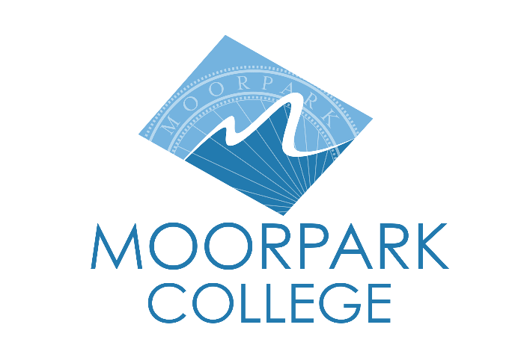
FOR IMMEDIATE RELEASE
Moorpark College Joins Forces with Lifetech Resources to Support Student Well-being
Donation of over 1,000 hygiene items strengthens commitment to student dignity and wellness
Moorpark, Calif. (May 30, 2025) — Moorpark College is proud to announce a new partnership with Lifetech Resources to provide essential hygiene products to students in need. A reception will be hosted at the college’s Raider Central Basic Needs Center on June 11 at 3 p.m. where Lifetech Resources will present a donation of 1009 bottles of 3-in-1 cleansers.
“At Moorpark College, we believe that student success begins with meeting their basic needs,” said Julius Sokenu, president of Moorpark College. “This generous contribution from Lifetech Resources allows us to further remove barriers to education by ensuring our students have access to essential hygiene products. We are grateful for this partnership and the shared commitment to uplifting our community.”
A leading Southern California contract manufacturer for beauty and personal care brands, Lifetech Resources is committed to uplifting local communities and operating with a "Beauty with a Purpose" philosophy, where true beauty extends beyond the surface to nurturing our communities.
"We are excited to partner with Moorpark College to provide basic hygiene needs for their students," states Shaffiq Rahim, CEO and president of Lifetech Resources. "We understand that every student's situation is unique, and we are incredibly grateful that Moorpark College actively supports their students with basic needs, allowing them to truly focus on their education."
The 3-in-1 cleansers will be available to Moorpark College students through the Raider Central pantry, a free resource that provides food and essential hygiene items such as shampoo, toothpaste, laundry soap, among others.
To learn more about Moorpark College’s Basic Needs services and how to access them, visit MoorparkCollege.edu/Wellness.
About Moorpark College
Moorpark College is one of three colleges in the Ventura County Community College District and annually serves more than 14,000 students. Founded in 1967, Moorpark College is fully accredited and has the highest six-year completion rate within the California Community College System. An Aspen Institute Top 10 Finalist for 2023 and 2025, Moorpark College has also been named a 2020 Champion of Higher Education by The Campaign for College Opportunity for the Associate Degree for Transfer Pathway. It is also a designated Hispanic-Serving Institution. The college’s signature career/technical programs include nursing, radiologic technology, biotechnology and journalism. The college’s America’s Teaching Zoo is the only associate degree exotic animal training program in the country. To learn more, visit MoorparkCollege.edu or follow @MoorparkCollege on social media.
Media Contact:
Debi Klein
dklein@vcccd.edu

