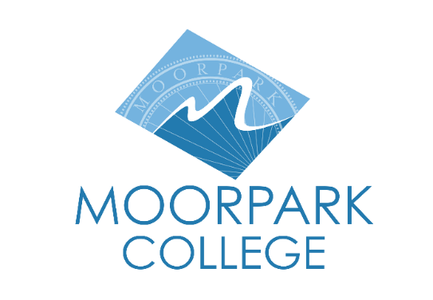

FOR IMMEDIATE RELEASE

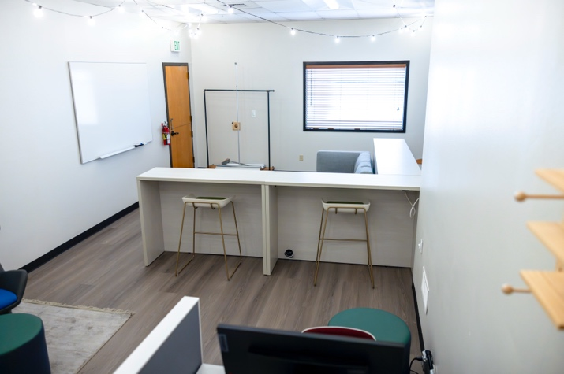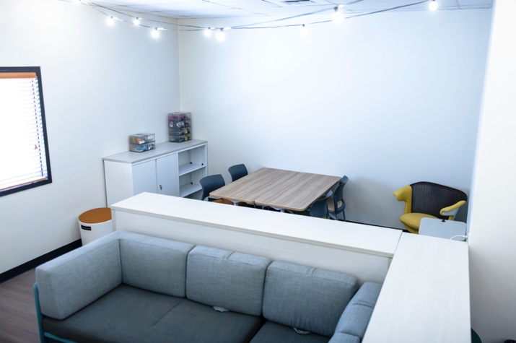

**Moorpark College to Host Grand Opening of New Pride Center**  
*New campus space will provide resources, support, and community for LGBTQIA+ students*

**Moorpark, California** (Feb. 24, 2025)—The Moorpark College community is delighted to announce the long-awaited grand opening of its Pride Center March 17. The grand opening and ribbon cutting event will take place in the Moorpark College Campus Center and adjacent Pride Center at 10 a.m. All are welcome.

Located in the Campus Center, this space was designed with significant input from students to ensure that it will be a warm and welcoming place for LGBTQIA+ individuals to thrive and be successful in their academic programs. Funded through grants from the state chancellor’s office and private organizations, the center has student computers, a small resource library, health vending machine and comfortable seating for informal gathering and MoorPride club meetings. The walls will provide a surface for student art.

“We look forward to sharing the grand opening of this affirming space with our community. We know that our LGBTQIA+ students will benefit mentally, emotionally and academically from a place to call their own,” said Julius Sokenu, president of Moorpark College.

Research shows that students do better in school when they feel a sense of belonging and that on-campus pride centers are an excellent way to help LGBTQIA+ students feel welcome and valued. Access to a campus pride center is long over-due and highly anticipated since about 30% of Moorpark College students identify as LGBTQIA+, according to the college’s most recent American College Health Association National College Health Assessment (ACHA-NCHA) findings in 2022.

The grand opening marks a milestone in Moorpark College’s ongoing commitment to fostering an inclusive and supportive environment for all students. To learn more about how the college is creating spaces that promote belonging and student success, [visit moorparkcollege.edu](https://www.moorparkcollege.edu/).

**About Moorpark College**

*Moorpark College is one of three colleges in the Ventura County Community College District and annually serves more than 14,000 students. Founded in 1967, Moorpark College is fully accredited and has the highest six-year completion rate within the California Community College System. An Aspen Institute Top 10 Finalist for 2023, Moorpark College has also been named a 2020 Champion of Higher Education by The Campaign for College Opportunity for the Associate Degree for Transfer Pathway. It is also a designated Hispanic-Serving Institution. The college’s signature career/technical programs include nursing, radiologic technology, biotechnology and journalism. The college’s America’s Teaching Zoo is the only associate degree exotic animal training program in the country. To learn more, visit* [*MoorparkCollege.edu*](http://MoorparkCollege.edu) *or follow @MoorparkCollege on social media.*

**Media Contact:**

Deborah Klein  
Chief Development Officer  
Moorpark College Foundation  
[dklein@vcccd.edu](mailto:dklein@vcccd.edu)  
805-553-4760