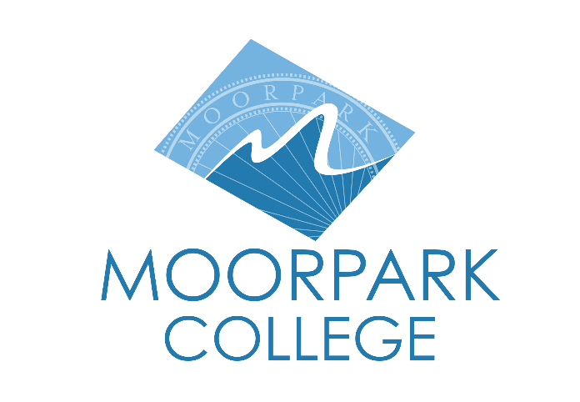
FOR IMMEDIATE RELEASE

MOORPARK COLLEGE DANCE PROGRAM PRESENTS TWO SPRING PERFORMANCES IN MAY
Motion Flux and Evening of Dance Celebrate Student Talent on the Performing Arts Mainstage

Moorpark, Calif. (April 30, 2026) — The Moorpark College Dance Program is pleased to announce two dance events this May that celebrate the talents and achievements of Moorpark College students on the Performing Arts Mainstage.

Motion Flux — May 8 and May 9
Motion Flux will be performed Friday, May 8, at 7:30 p.m. and Saturday, May 9, at 2 p.m. and 7:30 p.m. Directed by Robert Salas, Motion Flux is a formal concert dance performance with exquisite production value rooted in the aesthetic and the abstract. The program includes faculty- and student-choreographed works as well as guest artists.

“We are honored to welcome back Moorpark College dance alumna Kelsey Kleinman-Hollander as a guest choreographer, setting her contemporary dance style on the student ensemble, as well as the Mosaic Dance Company, the touring dance ensemble from CSU Dominguez Hills, directed by Amy Michele Allen, with choreographic work presented by Allen and Tia-Nischelle Turner,” said Robert Salas, director.

Eight Moorpark College student choreographers will also present original work: Carlos Contreras, Felix Galavis, Edwin Garcia, Madelaine Gonzales, Kamila Lopez, Josie Ocegueda, Lyssa Sullivan and Bri Yttri.

“Motion Flux has not only been an incredible opportunity to learn and utilize a stage, but it has given me a newfound source of community and belonging in the world of dance created at Moorpark,” said Felix Galavis, student choreographer.

Evening of Dance — May 18
Evening of Dance will be performed Monday, May 18, at 7 p.m. The show features performances by each of Moorpark College’s dance technique classes, from beginning to advanced levels, and includes a variety of styles: classical ballet, jazz, modern, tap and hip hop. Select student projects will be featured in the program, along with department awards recognizing awardees and degree recipients.
"It doesn't get better than this," said Beth Megill, artistic director. "Evening of Dance performances are where the students let it all hang out; they feel free to express themselves and take risks that are fun and fantastic. Not only does dance relieve the stress of the semester, but it celebrates the resilience and humanity that we all need right now."

Tickets for both performances are on sale now and may be purchased through the Moorpark College Performing Arts Center Box Office at (805) 378-1485 or online at moorparkcollege.edu/pac.

About Moorpark College
Grounded in equity, social justice, and a student’s first philosophy, Moorpark College values diverse communities. We empower learners from local, national, and global backgrounds to complete their degree, certificate, transfer, and career education goals. Through innovation and customized student support, our programs are designed to achieve equitable outcomes.
Moorpark College is one of three colleges in the Ventura County Community College District (VCCCD) and annually serves more than 14,000 students. Founded in 1967, Moorpark College is fully accredited and has the highest six-year completion rate within the California Community College System. An Aspen Institute Top 10 Finalist for 2023 and 2025, Moorpark College has also been named a 2020 Champion of Higher Education by The Campaign for College Opportunity for the Associate Degree for Transfer Pathway. It is also a designated Hispanic-Serving Institution. The college’s signature career/technical programs include nursing, radiologic technology, biotechnology and journalism. The college’s America’s Teaching Zoo is the only associate degree exotic animal training program in the country. To learn more, visit MoorparkCollege.edu or follow @MoorparkCollege on social media.

Media Contacts:
Beth Megill
Artistic Director, Dance Program
Moorpark College
(805) 378-4688
bmegill@vcccd.edu

Robert Salas
Director, Motion Flux
Moorpark College
rsalas@vcccd.edu

