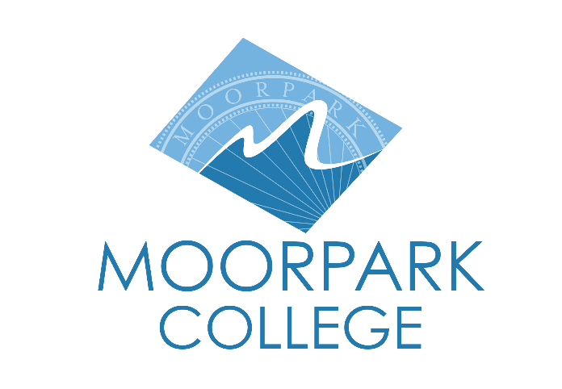
FOR IMMEDIATE RELEASE

MOORPARK COLLEGE THEATRE ARTS ANNOUNCES AUDITIONS FOR “THE IMPORTANCE OF BEING EARNEST”

Moorpark, Calif. (April 23, 2026) — The Moorpark College Theatre Arts Department is pleased to announce auditions for its upcoming Summer 2026 production of the classic Oscar Wilde comedy, The Importance of Being Earnest. Preliminary auditions will be held Tuesday, May 12, from 3:30–6 p.m. and Wednesday, May 13, from 6–10 p.m., with callbacks on Thursday, May 14, from 6–10 p.m. in the Studio Theatre, Room PA-100, of the Performing Arts Center on the Moorpark College campus.

Anyone interested in auditioning should be prepared to read from the script from audition sides posted on the Moorpark College Theatre Arts website at: moorparkcollege.edu/departments/academic/theatre-arts/auditions-and-rehearsals.

The Importance of Being Earnest by Oscar Wilde was written in 1895 and has delighted audiences across the globe for generations. This witty comedy of manners follows Jack Worthing and Algernon Moncrieff, who interchangeably adopt the persona “Earnest” to escape social obligations and woo women. Through farcical misunderstandings, invented identities, and satire of Victorian hypocrisy that echo through 2026 America, the play highlights the absurdity of class, marriage, and earnestness. This Wilde farce promises to be hilarious summer fun for the entire family!

“I’m so pleased to see the excitement that this production has already created in the Theatre Arts Department since we announced the summer production,” said John Loprieno, director and Theatre Arts faculty member. “This classic comedy features all of the tried-and-true comedic turns that any fun-loving audience would expect to see in a farce including mistaken identities, slamming doors, and high-energy chases. We’ll also be adding a few musical turns with the assistance of Musical Director Dave Watkins and Choreographer Nancy Ferraro-Paradis, so the Moorpark College Studio Theatre is the place you’ll want to bring the entire family this summer to come in from the heat and to sit back and laugh. Our summer productions also feature sets and props that are designed and constructed by our Technical Theatre students, and those classes are enrolling now — so we’re looking to have students join the fun on all levels this summer!”
There will be an informational meeting on auditions in the Studio Theatre, Room PA-100, on the Moorpark College campus on May 11 from 3:30–4:30 p.m. for anyone wanting to learn more about the production and the audition process. Anyone cast must enroll in the 3-unit Theatre Production: Performance class.

The Importance of Being Earnest will run July 16 through July 26, with evening performances Thursday through Saturday at 8 p.m. and Sunday matinees at 2 p.m. in the Studio Theatre on the Moorpark College campus. Tickets go on sale July 1 and may be purchased through the Moorpark College Performing Arts Center Box Office at (805) 378-1485 or online at moorparkcollege.edu/pac.

For additional information regarding The Importance of Being Earnest or the Moorpark College Theatre Arts Department, please contact director John Loprieno at (805) 378-1469 or jloprieno@vcccd.edu. Moorpark College is located at 7075 Campus Road in Moorpark, 93021.

About Moorpark College
Grounded in equity, social justice, and a student’s first philosophy, Moorpark College values diverse communities. We empower learners from local, national, and global backgrounds to complete their degree, certificate, transfer, and career education goals. Through innovation and customized student support, our programs are designed to achieve equitable outcomes.

Moorpark College is one of three colleges in the Ventura County Community College District (VCCCD) and annually serves more than 14,000 students. Founded in 1967, Moorpark College is fully accredited and has the highest six-year completion rate within the California Community College System. An Aspen Institute Top 10 Finalist for 2023 and 2025, Moorpark College has also been named a 2020 Champion of Higher Education by The Campaign for College Opportunity for the Associate Degree for Transfer Pathway. It is also a designated Hispanic-Serving Institution. The college’s signature career/technical programs include nursing, radiologic technology, biotechnology and journalism. The college’s America’s Teaching Zoo is the only associate degree exotic animal training program in the country. To learn more, visit MoorparkCollege.edu or follow @MoorparkCollege on social media.

Media Contact:
John Loprieno
Director, Theatre Arts
Moorpark College
(805) 378-1469
jloprieno@vcccd.edu

