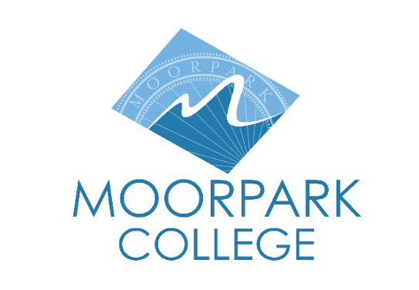
FOR IMMEDIATE RELEASE
Moorpark College Launches New Bachelor’s Degree in Applied Cyberdefense and Network Operations
New program opens doors to careers in one of the region’s fastest-growing industries
Moorpark, Calif. (Feb. 10, 2026) — Moorpark College has received full approval to offer a new Bachelor of Science in Applied Cyberdefense and Network Operations (ACNO), expanding high-quality, workforce-aligned bachelor’s degree options in Ventura County and strengthening the region’s cybersecurity talent pipeline.
The new applied bachelor’s degree program was designed in close collaboration with regional employers and public-sector partners to address growing demand for skilled cybersecurity and network operations professionals. Graduates will be prepared for high-wage, high-demand roles securing critical infrastructure, defense, healthcare, manufacturing, finance and emerging technologies across Ventura and Los Angeles Counties.
“This degree is about meeting our region where it is — and where it’s going,” said Julius Sokenu, president of Moorpark College. “By offering an applied bachelor’s degree in cyber defense and network operations, Moorpark College is creating a direct pathway for students to enter and advance in one of the fastest-growing fields in our economy, while also providing local employers with the highly skilled workforce they need.”
The ACNO program is expected to open applications later in 2026, following final implementation. In the meantime, students can enroll immediately in Moorpark College’s existing associate degree pathway in cybersecurity, which provides foundational technical skills and serves as a seamless on-ramp to the new bachelor’s program.
“By expanding bachelor’s degree offerings in areas like applied cyberdefense, we’re investing in regional resilience, economic mobility, and the kind of opportunity that transforms lives and communities,” said Rick MacLennan, chancellor of the Ventura County Community College District.
The curriculum builds on Moorpark College’s nationally recognized cybersecurity ecosystem. Moorpark College is designated as a National Security Agency (NSA) as a National Center of Academic Excellence in Cyber Defense (NCAE-CD), reflecting rigorous national standards in curriculum, faculty expertise, student outcomes and alignment with workforce and national security priorities. The program features hands-on laboratories, industry-aligned coursework and strong partnerships with business, defense and government organizations. Students will gain practical experience in cyber defense, secure network design, threat detection and incident response — skills employers increasingly require at the bachelor’s degree level.
“At its core, this program is about access, opportunity, and impact,” Sokenu said. “We are opening doors for students who want to stay local, serve their communities and build meaningful careers — while helping ensure our region and state are better prepared to meet today’s evolving cybersecurity challenges.”
The new program significantly strengthens educational options for students pursuing careers in cybersecurity and cyberdefense by providing an affordable, locally accessible bachelor’s degree pathway. For many place-bound, working, first-generation and veteran students, the ACNO degree offers a cost-effective alternative to relocating or enrolling in more expensive four-year institutions outside the region.
“Cybersecurity is a public good, and our students deserve the opportunity to lead in shaping it,” said Gabriela Torres, chair of the Ventura County Community College District Board of Trustees. “By creating pathways into cyberdefense that are built for equity and inclusion, we’re preparing a more diverse generation of leaders to protect the systems our communities rely on every day.”
The new ACNO degree joins Moorpark College’s existing bachelor’s degree in Biomanufacturing, further expanding advanced workforce pathways on campus. Together with bachelor’s degrees offered at Oxnard College (Dental Hygiene) and Ventura College (Automotive Career Education), the program reflects the Ventura County Community College District’s growing portfolio of applied baccalaureate programs designed to meet regional workforce needs while keeping education affordable and locally accessible.
To learn more about the Applied Cyber Defense and Network Operations program and Moorpark College’s Bachelor’s Degree Programs, visit MoorparkCollege.edu/BDP
About Moorpark College
Moorpark College is one of three colleges in the Ventura County Community College District and annually serves more than 18,000 students. Founded in 1967, Moorpark College is fully accredited and has the highest six-year completion rate within the California Community College System. An Aspen Institute Top 10 Finalist for 2023 and 2025, Moorpark College has also been named a 2020 Champion of Higher Education by The Campaign for College Opportunity for the Associate Degree for Transfer Pathway. It is also a designated Hispanic-Serving Institution. The college’s signature career/technical programs include nursing, radiologic technology, biotechnology, and cybersecurity. The college’s America’s Teaching Zoo is the only associate degree animal care and training program in the country. To learn more, visit MoorparkCollege.edu or follow @MoorparkCollege on social media.
Media Contact:
Zubi Ruth Olin
Program Director, Bachelor’s Degree Program
zubi_olin1@vcccd.edu
805-553-4769

