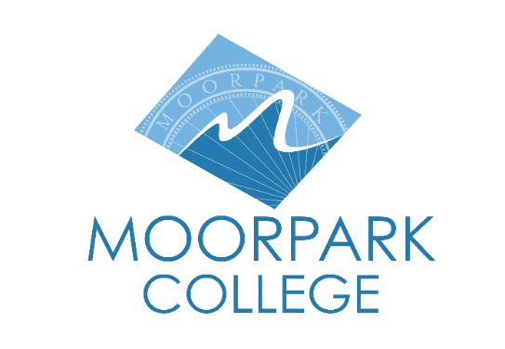

FOR IMMEDIATE RELEASE

Moorpark College Foundation Welcomes New Board Members in 2025/2026
New appointments underscore the Foundation’s ongoing commitment to students

Moorpark, Calif. (Feb. 4, 2026) — The Moorpark College Foundation is proud to announce the appointment of three distinguished community and industry leaders to its Board of Directors: Jacky Holler, Dr. Mark Mitchelson, and Tracey Mateko. Each brings deep professional expertise, a strong commitment to service, and a shared dedication to advancing educational access and student success at Moorpark College.

“The addition of Jacky Holler, Dr. Mark Mitchelson and Tracey Mateko strengthens the Foundation’s leadership with expertise spanning finance, healthcare, operations and community engagement,” said Dr. Julius Sokenu, president of Moorpark College. “Their collective experience and dedication will help advance our mission to support Moorpark College students and programs.”

Jacky Holler is Market Executive for Bank of America in Ventura and Santa Barbara counties. With more than 30 years of experience in financial services and over a decade with Bank of America, Holler is known for her collaborative leadership and ability to connect businesses, individuals and local communities to financial solutions and resources. Her career includes senior leadership roles in global operations, employee engagement, strategic planning and nonprofit executive service. Having served on numerous nonprofit boards and advisory committees, she holds a bachelor’s degree in Sociology from UCLA and an MBA from Pepperdine University.

Dr. Mark Mitchelson, DHA, RN, NEA-BC, FACHE, is a highly respected healthcare executive currently serving as Patient Care Executive and Associate Operations Executive at Adventist Health Simi Valley. In this dual role, he oversees clinical services, nursing operations and key ancillary departments, functioning at the level of Chief Operating Officer and Chief Nursing Officer. Dr. Mitchelson is widely recognized for driving operational excellence, improving patient outcomes and leading complex organizations through transformational change. His career spans executive leadership roles across major healthcare systems, including international service, with a strong track record of quality improvement, workforce stabilization and strategic growth. He holds a Doctorate in Health Administration, an MBA and a Bachelor of Science in Nursing.

Tracey Mateko is Regional Vice President at Logix Federal Credit Union, where she oversees branches in Simi Valley along with Virtual Channels and Real Estate Loan Officer Sales. With nearly 30 years in financial services, Mateko began her career as a teller and advanced into leadership through hands-on experience and a passion for helping others achieve financial stability. A longtime Moorpark resident, she has strong ties to the local community, including past service as a Rotarian. Mateko is especially committed to financial education and empowering individuals and families to reach their financial goals.

The Moorpark College Foundation supports the college by securing private funding for scholarships, instructional programs and campus initiatives that enhance student success and educational excellence. Learn more about the work the Moorpark College Foundation does at moorparkcollege.edu/community/foundation

About Moorpark College
Moorpark College is one of three colleges in the Ventura County Community College District and annually serves more than 14,000 students. Founded in 1967, Moorpark College is fully accredited and has the highest six-year completion rate within the California Community College System. An Aspen Institute Top 10 Finalist for 2023 and 2025, Moorpark College has also been named a 2020 Champion of Higher Education by The Campaign for College Opportunity for the Associate Degree for Transfer Pathway. It is also a designated Hispanic-Serving Institution. The college’s signature career/technical programs include nursing, radiologic technology, biotechnology and journalism. The college’s America’s Teaching Zoo is the only associate degree exotic animal training program in the country. To learn more, visit MoorparkCollege.edu or follow @MoorparkCollege on social media.

Media Contact:
Debi Klein
CDO, Moorpark College Foundation
805-553-4760

